Spanish Essentials Ideas and formatting

HI, Ed an Pedram,

Here are the general ideas for the putting together the material written towards the Spanish Essential site.

Please consider the folder the main page and each word document represents the individual mini-site

1. General presentation: We can follow either Arabic or Korean presentation. It will have an introductory text which says:

Spanish Essentials

Spanish Essentials concentrates on basic language. The _______ sections cover the key spoken and written language essential for communication. You can listen to spoken Spanish to learn and practise how to greet others and get to know them, learn Spanish numbers, and talk about times and dates, and talk about nationalities and jobs. Learning Objects offer a range of small, independent resources that can be used either as part of a course or for self-study. (Please note, each topic will open in a new tab or new window depending on your browser set up.)

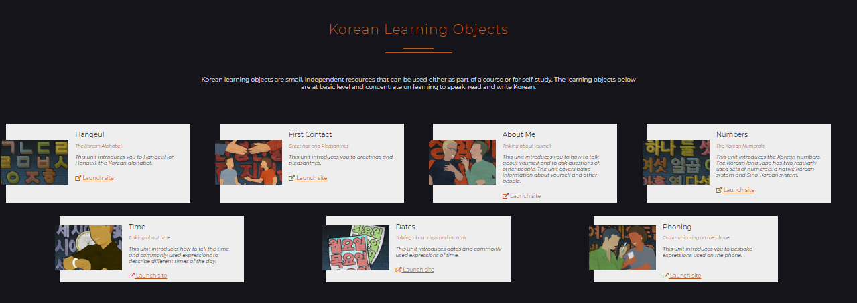

1. The content will follow the same organization and presentation that the Korean Learning objects

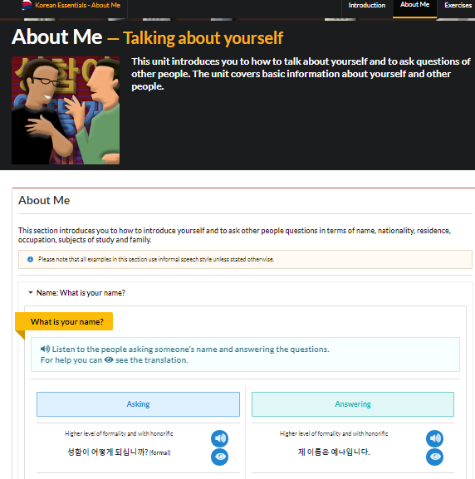

1. Each sentence must go accompanied by audio. Also, at the end of each unit will have activities to assess understanding
2. We will have 8 Units – sections or mini sites (Please feel free to create beautiful icons with lots of colour for each mini- section) (this images are just for fun 😊) the sections to create are:

* First contact 
* Alphabet 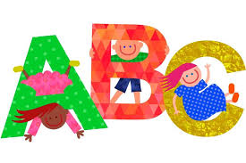
* Numbers 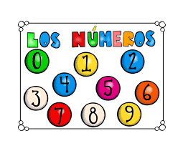
* All about me 
* Descriptions 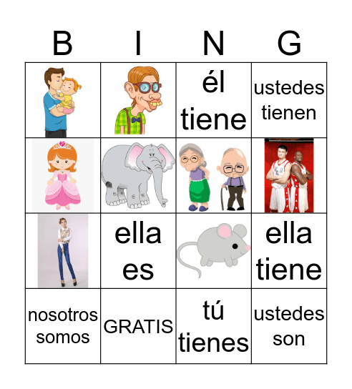
* Telling the Time 
* Calendar and weather 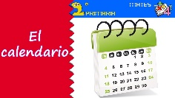
* Essential Grammar 